Circular No : URA/PB/2009/08-CUDG
Our Ref : DC/ADMIN/CIRCULAR/PB_09 Fax : 6220 3201
Date : 29 April 2009

CIRCULAR TO PROFESSIONAL INSTITUTES

NIGHT LIGHTING MASTER PLAN OF DEVELOPMENTS IN THE CENTRAL BUSINESS DISTRICT (CBD), MARINA CENTRE AND MARINA BAY

Objective
- The Night Lighting Master Plan for the Central Business District (CBD), Marina Centre and Marina Bay (Master Plan) is to guide the lighting up of developments to achieve a unique, three-dimensional nightscape for CBD, Marina Centre and Marina Bay area (see Appendix 1). This Master Plan is realised incrementally as and when new buildings are developed and when existing buildings redevelop or undergo major refurbishment.
- The Guidelines in this document are to help realise the vision for a congruous, harmonious and well-coordinated signature nightscape, for the day-to-day night lighting of buildings as well as during festivals and national events. The Guidelines provide a recommended framework for the lighting treatment of key building elements, including the covered walkways, building facades, sky gardens and building crowns. They also highlight practical issues, such as light trespass, light pollution, light fitting details, as well as energy efficiency and maintenance, which should be considered upfront at the design stage. The Guidelines can be found in Appendix 2.
- Arising from feedback that the night lighting design should take cognizance of the lighting design of surrounding developments, URA is pleased to introduce the Night Lighting website at - http://www.ura.gov.sg/lightingplan, where all approved lighting design for developments in the CBD, Marina Centre and Marina Bay will be uploaded for reference. The guidelines on Good Lighting Practices can also be found on this website.
- All developments within the Master Plan boundary are required to provide night lighting in compliance with the prescribed night lighting guidelines.
- This Circular supersedes the earlier Circulars URA/PB/2006/06-CUDD released on 24 March 2006 and URA/PB/2007/10-CUDD released on 5 November 2007.

Effective Date

With effect from 29 April 2009

Who should know?

Architects, lighting designers, building owners and developers.

Definition of Night Lighting Design and Fixtures

- The night lighting design under the Master Plan refers to the lighting up of the exterior of the building to highlight the design of the development, particularly the building crown, façade, main architectural features of the building, sky gardens and the pedestrian areas at street level, using permanent lighting fixtures.

- The light fixtures are encouraged to be designed and well-integrated with the overall design of the building and integrated into the building façade or within a building element, such as the roof feature or sun-shading devices. The entire lighting fixture shall be located and installed fully within the boundary of the development.

- The night lighting design will be evaluated under the following categories:

  - Basic Night Lighting - defined as the daily elegant, tasteful and sensitive lighting up of the architecture of the building to complement the overall skyline of the city at night; and

  - Special Night Lighting - defined as special night lighting to accompany a specific festival or event. Special Night Lighting installations are fittings which can be programmed to complement and contribute to different festivals or events held in and around the Marina Bay (e.g. National Day Parade, Formula 1 Grand Prix and New Year’s Eve Countdown).

- As a guide, the daily night lighting shall be elegant, tasteful and sensitive to the architecture of the building and well-coordinated with the overall night time skyline. Animated night lighting sequences for daily lighting up of the building are discouraged. Festival or event night lighting shall relate to and complement the theme of the festival or event. A separate detailed festival night lighting proposal shall be submitted for each event for URA’s1 evaluation and approval. Specific guidelines may be provided by the URA or the appointed event organiser to ensure coordination of the festive night lighting of developments around the Marina Bay.

1
The term "URA" is used in this Circular as a convenient reference to mean ‘the Chief Executive Officer, URA, as the
Competent Authority (CA) under the Planning Act’.

Submission and Evaluation Process

- All developments within the existing CBD, Marina Centre and Marina Bay, are required to provide night lighting under the Night Lighting Master Plan, in accordance with the prevailing guidelines. See Appendix 1 for the boundary of the Night Lighting Master Plan.

- All night lighting proposals shall be submitted formally to URA’s Development Control Group for approval as part of the Development Application process, using the submission form attached in Appendix 3. To ensure that the external building lighting installation is considered as an integral part of the design of the development, the night lighting proposal must be submitted as part of the development plans at the Provisional Permission (PP) stage.

- To facilitate the submission of night lighting proposals, URA has drawn up a checklist of submission requirements (see Appendix 4). The checklist provides a step-by-step guide on the design issues to be addressed from the overall lighting concept to detailed proposals. The checklist also lists all the supporting drawings and technical information which needs to be submitted to facilitate the evaluation of the lighting proposal.

- The Night Lighting design shall minimally focus on the:
      - Covered Walkways and Public Spaces at the First Storey;
      - Façades of the buildings visible from the surrounding roads and public spaces;
      - Sky Gardens; and
      - Building Crown.

- All night lighting proposals will be evaluated by the URA with the assistance of a Lighting Design Advisory Panel (LDAP), comprising industry experts.

- Approval of the night lighting proposal is subject to:
- The approval of the night lighting proposal (including cost estimate for developments applying for the incentives) by the URA and in consultation with the LDAP;
- Submission of Letter of Undertaking to comply with all prevailing operating requirements, for daily night lighting and during festivals and events;
- Compliance with all other planning and urban design requirements for the site; and
- The retention, operation and maintenance of the approved night lighting at the owner’s own cost and expense.

- The external night lighting must be reflected in the proposal plans for the development for the URA’s approval. A retention clause will be included as a condition in the WP for the development to ensure that the night lighting is retained and operated and will be enforced through the Planning Act on the owner and any subsequent purchaser of the development.

- Any changes to the approved night lighting proposal for the development (e.g. change in lighting concept, type of lighting equipment, specifications of the lighting equipment), are required to be submitted to the URA for evaluation and approval.

- The entire night lighting proposal, including all external building lighting installation, shall be installed and commissioned according to the approved plans and verified and endorsed by URA under the Planning Act. URA's clearance of the completed Night Lighting Installation is required before the Commissioner of Building Control issues the Temporary Occupation Permit (TOP), or Certificate of Statutory Completion (CSC) (in the event the TOP is not required). See Appendix 4 for details of submission requirements and process for seeking Provisional Permission (PP), Written Permission (WP) and the clearance for completed works under the Night Lighting Guidelines. The standard processing time to evaluate and approve a complete and compliant submission of completed works is about 4 weeks. Please note that a longer processing time may be required if the submission is incomplete or not in order. The Applicant is to ensure sufficient lead time is allowed to secure the clearance prior to applying to the Commissioner of Building Control for TOP/CSC. The submission is required to include labeled and annotated photographs (in .pdf file format) showing the completed night lighting installation on site. URA will evaluate the photographs submitted and, if necessary, arrange for a site inspection before issuing the clearance letter for the completed works.
- Applicants are also required to declare upfront to the Commissioner of Building Control at the point of application for TOP or CSC (in the event the TOP is not required), that URA’s clearance is required for the night lighting before issuance of TOP, or CSC (in the event the TOP is not required). TOP/CSC will only be granted by BCA after the night lighting has been satisfactorily installed on site.

- If the external lighting fixtures are not installed and commissioned according to the approved plans, the Applicant or Building Owner will be required to revise the lighting installation to match the previously approved lighting design or provide reasons for the deviation for the URA evaluation and approval.

- The night lighting fixtures are to be retained and maintained throughout the entire life of the building and shall not be removed without the prior approval of the URA.

Operation Hours and Maintenance of the Night Lighting

- Building owners are required to minimally turn on the night lighting from Friday to Sunday, 7pm to 11pm, according to the approved night lighting proposal and the guidelines outlined in Appendix 2. The lighting up of the building outside the recommended hours of Friday to Sunday, 7pm to 11pm, shall be in accordance with the approved night lighting proposal and the guidelines in this circular.

- The operation of the special night lighting shall be guided by the detailed theme for the festival / event and any guidelines which are issued for the festival or event and submitted for URA’s approval.
- Owners of buildings located within the Master Plan boundary, in particular those that front on to Marina Bay or form part of the city skyline as seen from Marina Bay, are required to turn on their basic and special night building lights during national events and festivals according to the requirements to the URA.

- I would appreciate it if you could convey the contents of this circular to the relevant members of your organisation. If you or your members have any queries concerning this circular, please do not hesitate to contact Senior Architect Bernard Chan at 6321 8243 (email: Bernard_chan@ura.gov.sg) or our DCG Enquiry Line at Tel: 6223 4811 (email: ura_dcd@ura.gov.sg). We will be pleased to answer queries on this, and any other development control matter. For your information, the past Circulars to the professional institutes are available from our website http://www.ura.gov.sg.

Thank you.

FUN SIEW LENG
GROUP DIRECTOR (URBAN PLANNING & DESIGN) for CHIEF EXECUTIVE OFFICER
URBAN REDEVELOPMENT AUTHORITY

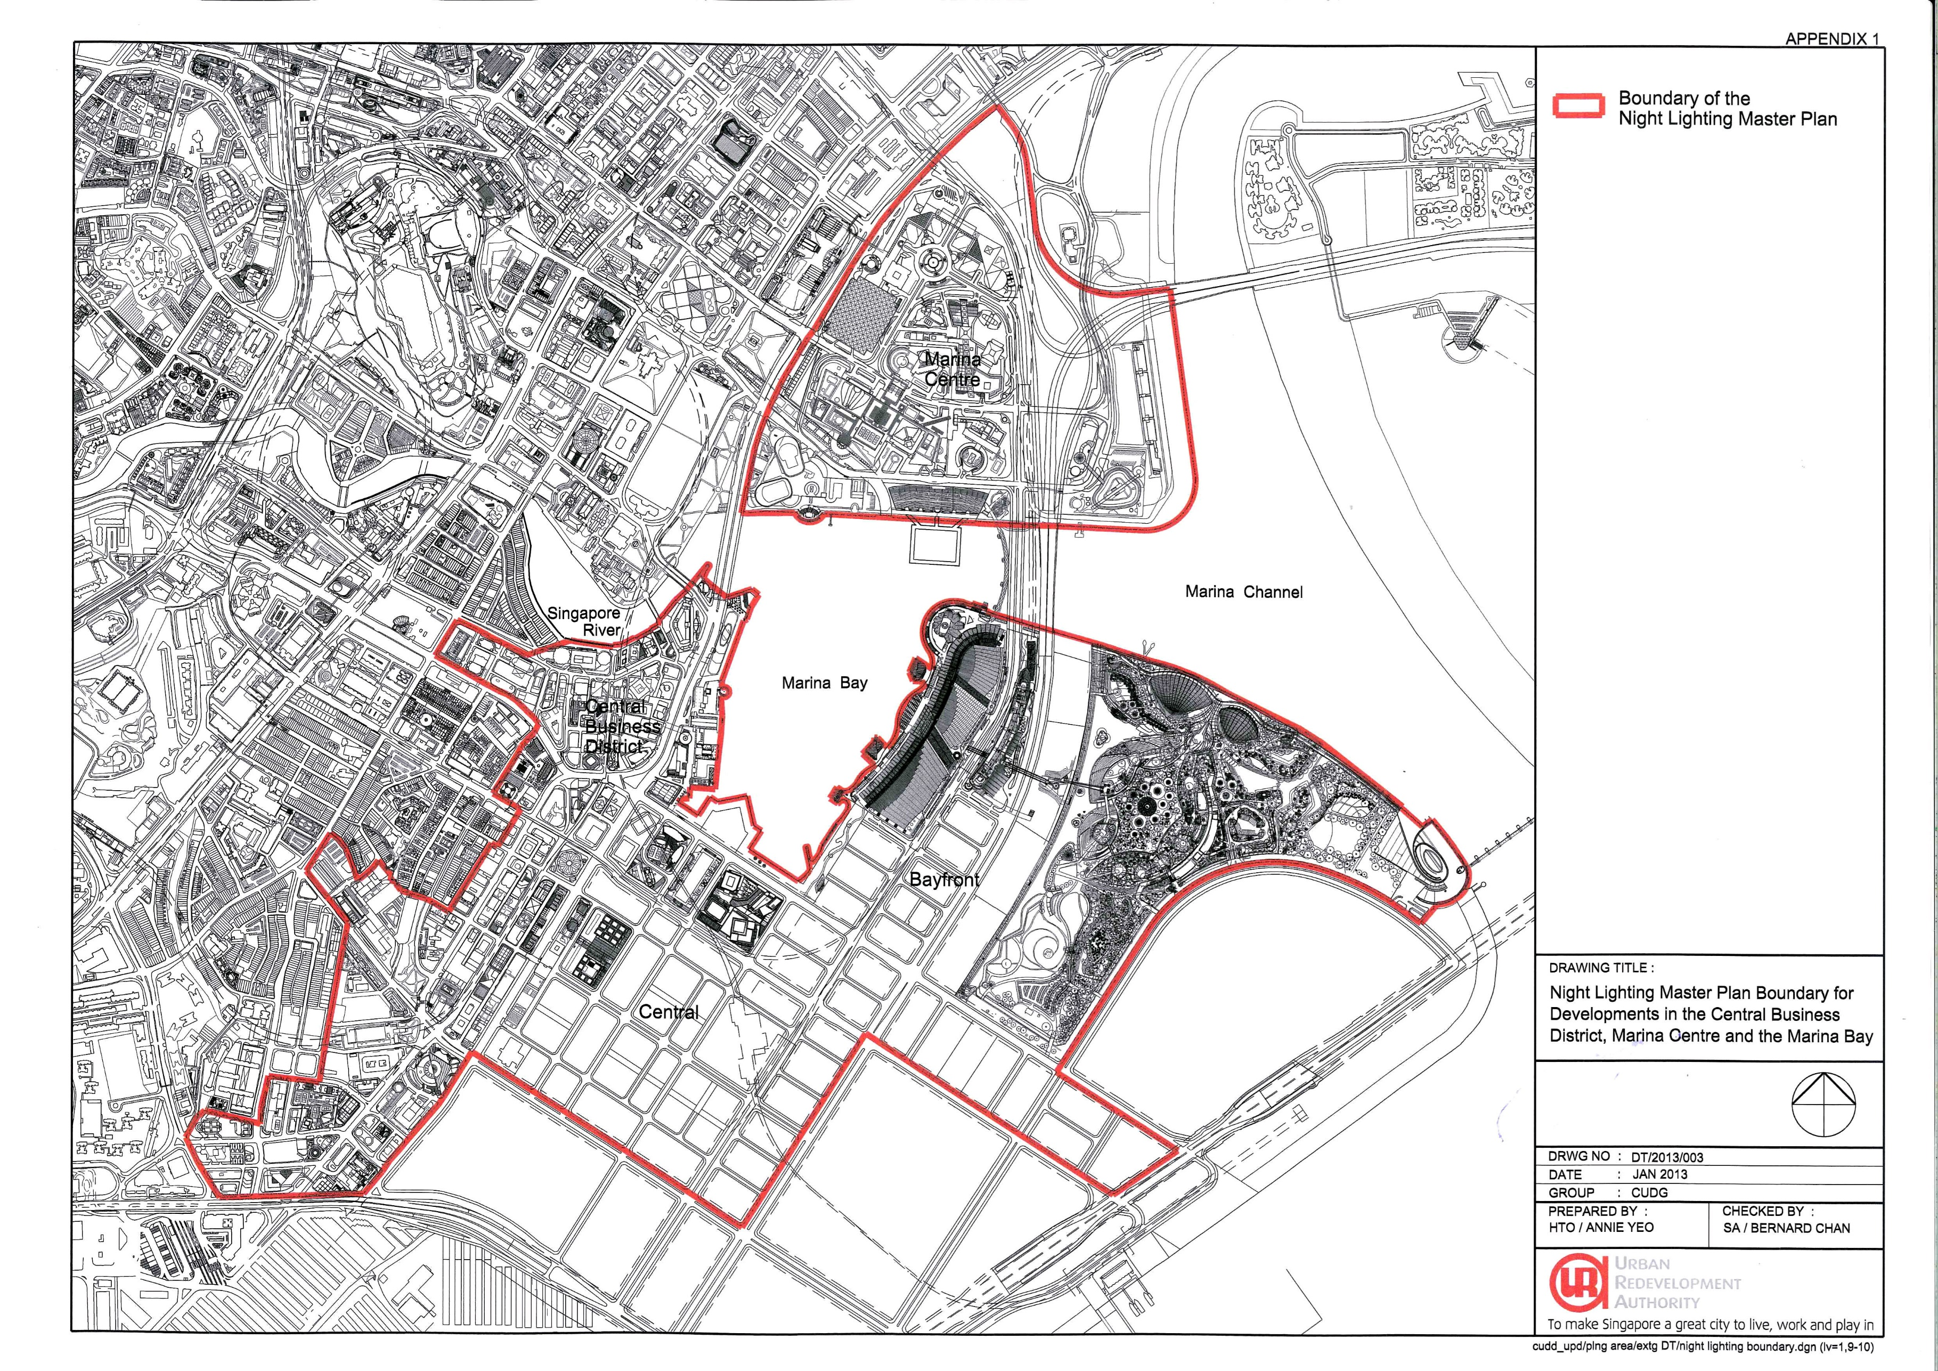

APPENDIX 2

GUIDELINES FOR THE EXTERNAL NIGHT LIGHTING OF DEVELOPMENTS IN THE CENTRAL BUSINESS DISTRICT (CBD), MARINA CENTRE AND MARINA BAY

- Good night lighting can help to transform and enhance the image of the city by improving the appearance of the city at night. Not only will good night lighting make the city more appealing for activities after dark, it can also be an attractive promotional asset that has tangible economic benefits, such as supporting the tourism sector and attracting investment.

- The night lighting plan for the city centre aims to enhance and emphasise Singapore's unique features as a tropical metropolis and garden city. As the developments that form Singapore’s signature skyline lie largely within the existing Central Business District (CBD) Marina Centre and Marina Bay, URA will require these developments to participate in realising the plan by incorporating external night lighting as part of the overall building design, particularly at the building crowns, main architectural features of the building, sky gardens and the pedestrian areas at street level.

- The night lighting guidelines for CBD, Marina Centre and Marina Bay aim to provide a cohesive urban nightscape where night lighting will serve to tie up various architectural elements for each development, with specific guidelines for each architectural feature.

- Supplementary information on Good Night Lighting Practices can be found on the URA website at – www.ura.sg/lightingplan/.

Night Lighting Concept for the Skyline

- Night lighting of the building crowns help to create a unique, three- dimensional skyline for the city. A strategic colour temperature plan recommends that low and mid-rise structures use lights of a lower colour temperature at their building crowns, while high-rise structures should use higher colour temperature lights, to create a colour gradation effect for the skyline.

- The night lighting guidelines as shown in Table A are for the building crown, sky gardens, façade and covered walkways and public spaces at the first storey. There is flexibility within each guideline on the method of lighting to achieve the objective of enhancing the key architectural design characteristics, personality and principal use of each building.

Light Trespass and Light Pollution

- There is a growing concern about the excessive use of lights to illuminate the cityscape. Night lighting should thus be executed sensitively to avoid glare, light trespass and light pollution. Pedestrians, residents, drivers, and other fields of vision shall be considered to prevent light spillage and to increase the energy efficiency of the lighting.

Light Fittings and Mounting Details

- Sufficient measures must be taken to ensure that night lighting fixtures and mounting details are fully integrated with the architecture and/or landscape design of the building and screened from view.

- The night lighting equipment shall have necessary protective means from damage, theft and harm to the public, for those elements that are accessible to the public.

Energy-Efficient and Maintenance-Friendly

- Light sources that have a high energy-efficiency rating, have a long operating life for easier maintenance, and are of high economical efficiency, such as compact metal halide lamps, fluorescent lamps, LEDs, or electrodeless lamps, are recommended for use.

Special Lighting

- Building owners may choose to include special night lighting. Such fittings should be submitted at the same as the basic night lighting. However special lighting which differ from the previously approved night lighting proposal shall be submitted separately to the URA for approval before execution on site. The operation of the special night lighting will be guided by the detailed theme for the festival or event and shall be submitted to URA for detailed evaluation and approval.

Operation Hours

- Building owners are required to minimally turn on the lights from Friday to Sunday, 7.00pm to 11.00pm, according to the approved lighting proposal. Lighting up of the building outside the recommended hours of Friday to Sunday, 7.00pm to 11.00pm shall be in accordance with the approved lighting proposal and the prevailing guidelines in this Circular.

- The operation of the special night lighting shall be guided by the detailed theme for the festival / event and any guidelines which are issued for the festival or event and submitted for URA’s approval.

- Owners of buildings located within the Master Plan boundary, in particular those that front on to Marina Bay or form part of the city skyline as seen from Marina Bay, are required to turn on their basic and special night building lights during national events and festivals according to the requirements to the URA.

Lighting Mock-up / Lighting Trials

- The testing and commissioning of the approved lighting proposal must be done in a manner which does not become a disamenity to the surrounding developments and does not have an adverse impact on the night time skyline. As a guide, the testing of the light fittings should be done either during day-light hours or between the hours of 11.00pm and 4.00am. Building owners are required to submit their testing and commissioning schedules to URA at least 3 days before site testing, for URA’s records.

- Building owners are required to liaise and coordinate the testing of the lighting for special events (e.g. National Day Celebration, New Year’s Eve Countdown) with the event organiser via the URA.

Publication

- The building owner is to allow URA to publish the approved lighting design on URA’s website once Written Permission for the lighting proposal has been granted. This will serve as a reference for the design of the night lighting of subsequent adjacent developments to ensure an appropriate design response.

APPENDIX 2 – TABLE A

TECHNICAL GUIDELINES FOR THE EXTERNAL NIGHT LIGHTING OF DEVELOPMENTS IN THE CENTRAL BUSINESS DISTRICT (CBD), MARINA CENTRE AND MARINA BAY

Building Part | Type / Building Height | Color Temperature  (Kelvin) | Color Rendering  Ra | Illuminance (Lux) | Signage | Moving Lights | Operating Hours | Proposal*
Building Crown | 1.  Commercial/Office |  |  | No control on lux level. However, lighting shall be executed sensitively to avoid glare, light trespass and light pollution. | No advertisement signages are allowed. Current signage guidelines are applicable. | Discouraged. Moderate, slow-moving kinetic lighting may be considered, based on the merits of the proposal & site adjustment | Encouraged to turn on lighting from Friday  - Sunday, 7pm-11pm, and during national events and celebrations  .
 | - Bldg Ht >151m  - Bldg Ht =36m-150m  - Bldg Ht < 35m | 4500 - 6000K  3500 - 4500K  2500 - 3500K | > 70  > 70  > 70
 | 2. Residential/Hotel
 | - Bldg Ht >151m  - Bldg Ht <150m | 3500 - 4500K  2500 - 3500K | > 70  > 70
 | 3. Mixed-use
 | - Bldg Ht >151m  - Bldg Ht =36m-150m  - Bldg Ht < 35m | 4500 - 6000K  3500 - 4500K  2500 - 3500K | > 70  > 70  > 70
Skygardens | Roof Garden
 | - Tree Uplighting | 4200K | > 70
 | Mid-level Gardens
 | - Tree Uplighting  - Soffit Space | 3000K  3000K | > 70  > 70
Façade | 1. Commercial | 3500-6000K | > 70
 | 2. Office | 4500 - 6000K | > 70
 | 3. Residential/Hotel | 2500 - 3500K | > 70
 | 4. Complex | 3500 - 6000K | > 70
Covered Walkways |  | 2500 - 3500K | > 80 | Ave floor Lux :
 |  |  |  | Downlight:50- 200
 |  |  |  | Indirect light:20-100
Public Spaces (Landscaped areas / Plazas) |  | 2500 - 3500K | > 80 | Ave Lux >5 lux

* To be filled in by Applicant. State "Complied, NA or Do Not Comply (provide justifications)"

SUBMISSION FORM FOR NIGHT LIGHTING OF DEVELOPMENTS IN THE CENTRAL BUSINESS DISTRICT, MARINA CENTRE AND MARINA BAY

PART I PARTICULARS OF PROJECT
Development Name
Description of Project
Location
Lot No |  |  | TS/MK No
Application for:

- Additional GFA Incentive (for new developments, redevelopment and major A&A projects)

- Cash Grant Incentive (only for existing developments fronting Marina Bay or that contribute to the skyline as seen from Marina Bay)
Has Provisional Permission/ Written Permission been obtained for the development? |  |  |  | - Yes  - No
If yes, please attach a copy of the Grant of PP/WP
Ref No |  |  | Decision No
PART II PARTICULARS OF THE APPLICANT (OWNER / DEVELOPER)
Name of Firm
Address
Tel No |  |  | Fax No
Name of person for contact
PART III PARTICULARS OF THE QUALIFIED PERSON
Name of Firm
Address
Tel No |  |  | Fax No
Name of person for contact
PART IV PARTICULARS OF THE PROFESSIONAL QUANTITY SURVEYORS
Name of Firm
Address
Tel No |  |  | Fax No
Name of person for contact

PART V DESCRIPTION OF LIGHTING PROPOSAL
Please include a separate detailed write-up and any other supporting materials, documents or information, e.g., detailed models, simulations, plans, etc that you deem will help to illustrate and support your proposal.
The attached submission must include the following:
Sn | Items | Checklist
i) | Concept of lighting design and installation;
ii) | Simulations / artist’s impression showing the external building lighting proposal in the context of the surrounding (For developments visible from Marina Bay, the artist’s impression shall be a view from Marina Bay, using the base rendering provided in URA’s website);
iii) | Annotated plans, elevations and other drawings to a suitable scale;
iv) | Specifications of lighting fixtures;
v) | Installation methods;
vi) | Specifications of lighting levels and colour temperature;
vii) | Name of lighting designer (if relevant);
viii) | Energy efficiency standards of the proposed lighting installation;
ix) | Artist’s Impression using the Night Time Skyline Rendering provided in Appendix 5 and 6, together with an endorsement by building owner granting URA, permission to publish the approved night lighting scheme on URA’s Night Lighting website; and
x) | Letter of Undertaking to comply with the operating requirements as set out in the prevailing guidelines
Please list down and itemise the additional information that is included in the submission.
PART VIII DECLARATION
I/We certify that the particulars and the information given in this application are true and correct

Name & Signature of Applicant (Owner/Developer) Date

Name & Signature of Qualified Person Date

SUBMISSION REQUIREMENTS CHECKLIST

- Write-Up with Appropriate Illustrations

Overall Night Lighting Concept

  - Please describe the overall Architectural Concept adopted for your building in response to the uses within the development and the surrounding context. Please also explain how the Architectural Concept is expressed in terms of the overall plan, building form and façade and roof design.

  - Please describe the night lighting concept and how it enhances and complements the architectural concept for the building.

Detailed Night Lighting Proposals

- Please describe the detailed night lighting proposal for the building. In particular, how the night lighting proposal relate to the specific uses within the development, the architectural design of the façade, roof crown and the surrounding context.

- Please provide details of the night lighting proposals for each of the following components of the building – e.g. at the main entrance; street / shopfront; podium; tower; and roof levels. Please also explain how the proposed night lighting to these areas contributes to the overall night lighting concept.

- Please provide a summary of the lighting proposal using the format provided in Appendix 5 for the URA to include in the Night Lighting website once the lighting proposal is approved.

Drawings

  - Please provide detailed drawings showing the proposed locations of all the proposed light fittings to achieve the desired overall night lighting concept and accentuate the architectural design of the façade and roof areas.

  - The detailed drawings should include mounting details to illustrate how all the different lighting fixtures are integrated into the architectural detailing of the façade and roof areas. All night lighting fixtures should, as far as possible, be integrated with the external building elements/facade/special architecture features.

  - Please also submitting details illustrate the measures taken in the choice and placement of the light fittings to ensure that they do not result in light spillage into the building or the adjacent developments.

of your development shall have a resolution of at least 300 dpi, prepared using Adobe Photoshop, saved on a separate layer for the URA to transfer into its high resolution rendering.

c. Additional views of the detailed lighting at each of the individual zones of the building may be provided to further illustrate specific features of the proposal.

Technical Information

  - Please provide illustrations of each of the light fittings together with their full technical specifications. Please also provide reasons for your selection and how the proposed fittings best achieves the desired overall lighting concept.

  - Please fill in and submit Appendix 2 - Table A showing the proposed lighting levels of various part of the exterior building facades, roof crown architecture features, roof/sky garden(s), street levels and landscape area. Please use Appendix 2 - Table A to declare your compliance with the prevailing guidelines. Where the proposal deviates from the guidelines, please provide justifications for your alternative proposal, in relation to the architectural and night lighting concept, for our evaluation and consideration.

  - Please indicate the quantity of light fittings on the lighting layout plans.

  - Please illustrate how the glare to the surrounding buildings is minimised.

  - Please indicate the energy efficiency for the proposed external lighting. Please note that you are to ensure that the energy efficiency is to be equal to or less than 5 Watts per sqm.

For Clearance of Completed Works

  - The Lighting Installations shall be implemented according to the approved plans and verified and endorsed by the URA under the Planning Act. URA’s clearance of the completed Lighting Installations is required before the Commissioner of Building Control issues the Temporary Occupation Permit (TOP), or Certificate of Statutory Completion (CSC) (in the event the TOP is not required). The building owner is to submit confirmation of the completed works to URA to seek URA’s clearance of the completed Lighting Installation. The standard processing time to evaluate and approve a complete and compliant submission is about 4 weeks. Please note that a longer processing time may be required if the submission is incomplete or not in order. The Applicant is to ensure sufficient lead time is allowed to secure the clearance prior to applying to the Commissioner of Building Control for TOP / CSC.

  - Your submission is required to include accurately labeled photographs (in pdf file format) showing the completed Lighting Installations. URA will evaluate the photographs submitted and, if necessary, arrange for a site inspection before issuing the clearance letter for the completed works.

  - Applicants are also required to declare upfront to the Commissioner of Building Control at the point of application for TOP or CSC (in the event the TOP is not required), that URA’s clearance is required for Lighting Installations before issuance of TOP, or CSC (in the event the TOP is not required).

APPENDIX 5

NIGHT LIGHTING PROPOSAL

Night Lighting Design for | (Name of Development)
Name of Qualified Person | (Name of Qualified Person)
Name of Lighting Designer | (Name of Lighting Designer/s)
Summary of the Approved Night Lighting Design (in font 10 - Arial)
Please insert Night Lighting Rendering(s) here

Please limit to 1 page

I,
(owner / developer)
(name of development), give

consent to the Urban Redevelopment to post the above details on its official website once Written Permission for the lighting proposal has been granted.

Name: _________________ Signature: ____________ Date: _________

APPENDIX 6

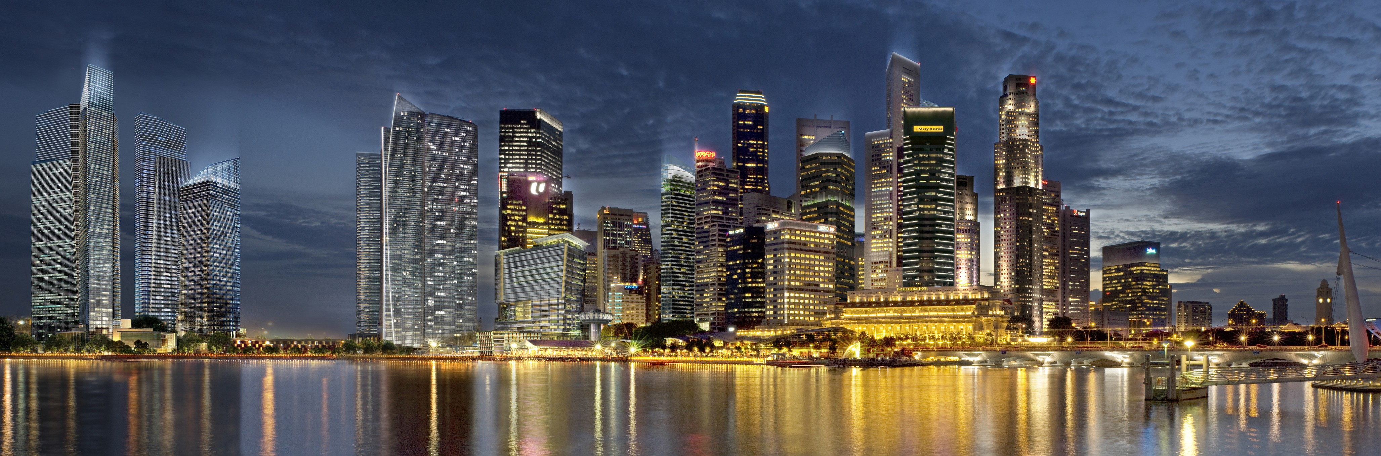

All Night Lighting Submissions are to be accompanied with a rendered perspective of the building to illustrate the night lighting in context with the overall skyline of the area when viewed from Marina Bay, using the Night Time Skyline rendering above.

Note - The night time rendering shall have a resolution of at least 300 dpi, prepared using Adobe Photoshop, saved a separate layer for URA to transfer into its high resolution rendering.

